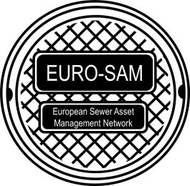Feedback from the 4th EURO-SAM Workshop
The last edition of the EURO-SAM (EUROpean – Sewer Asset Management) workshop has been held the 6th and 7th June 2016 in Strasboug, France, hosted by Irstea-Engees. The strikes in France didn’t stop the 23 participants from seven countries to share their recent research results and to reinforce their collaboration with European (and Colombian) researchers. 17 presentations have covered the following topics: deterioration modelling, data issues (availability and reliability), operational management, monitoring, urban development, cost analysis, multi-asset management, rehabilitation strategies and integrated approach.
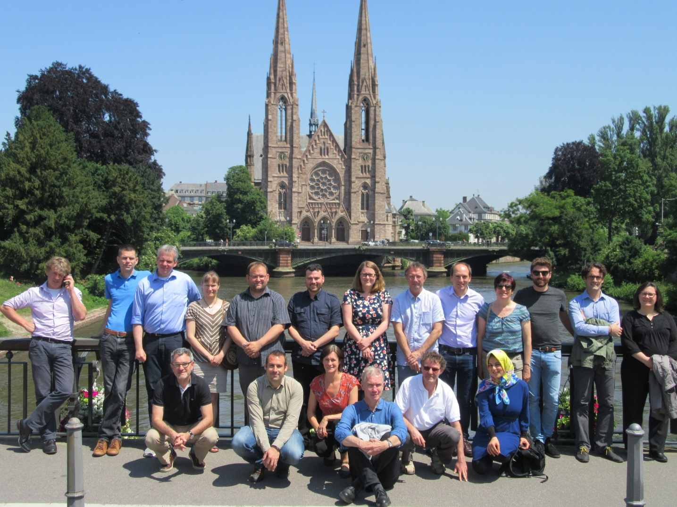
The EURO-SAM workshop is always free of charge and is open to any researcher (even if the number of participants is limited). Participants are invited to present their current research, and time is dedicated to collaborative work in order to find out shared topics and define further collaborations between participants.
In 2017, there will be no EURO-SAM workshop and all researchers are invited to attend to the LESAM 2017 conference in Trondheim. In 2018, the EURO-SAM workshop will be hosted by the Unit of Environmental Engineering of the University of Innsbruck, and organized by Franz Tscheikner-Gratl and Manfred Kleidorfer.

The 2016 EURO-SAM workshop organizing committee would like to thank again all participants.
Caty Werey (Irstea – Engees joint research unit GESTE, Strasbourg), Nicolas Caradot (KWB, Berlin) and Frédéric Cherqui (INSA, Lyon).

